EVO Nano Standard Package Gray, Autel
EVO Nano Premium Bundle Gray, AutelDJI Mavic 3
649,00 €

Super Sharp. Ultra Smooth.
The EVO Nano is equipped with a 48MP camera that can record ultra sharp 4K/30fps video. Paired with a three-axis mechanical gimbal to prevent vibration, the Nano provides everything you need to ensure your footage is smooth and stable no matter how rough the conditions.
- 1/2″ CMOS 3-axis Gimbal
Available on back-order

In the Box
1 | Aircraft (including battery, propellers and gimbal cover) | 1x
2 | Remote Control | 1x
3 | Spare Propellers (pair) | 1x
4 | USB-C Charging Cable | 1x
5 | RC Cable | 3x
 | -Micro-USB Connector
 | -Lightning Connector
 | -USB-C Connector
6 | Spare Screws | 8x
7 | Screwdriver | 1x
8 | Manuals | 3x
 | -Packing List
 | -Disclaimer and Safety Operation
 | Guidelines
 | -EVO Nano Series Quick Start Guide

Aircraft
Takeoff Weight (without Accessories) | 249g
Dimensions (including blades) | Folded: 142×94×55mm  Unfolded: 260×325×55mm
Wheelbase | 231mm
Max Ascent Speed | 6m/s (sport), 4m/s (normal), 3m/s (stable)
Max Level Flight Speed | 4m/s (sport), 3m/s (normal), 2m/s (stable)
Max Level Flight Speed(no wind, near sea level) | 15m/s (sport), 10m/s (normal), 5m/s (stable)
Max Takeoff Altitude | 4000m
Max Flight Time (no wind) | 28min
Max Hovering Time (no wind) | 26min
Max Flight Distance (no wind) | 16.8km
Max Wind Resistance | Level 5
Max Tilt Angle | 33°(movement), 25°(normal), 25°(stable)
Max Angular Velocity | 200°(movement), 120°(normal), 60°(stable)
Operating Temperature | -10°C ~ 40°C
Operating Frequency | 2.400-2.4835GHz，5.725-5.850GHz,5.150-5.250GHz
Transmission Power (EIRP) | FCC:≤30dBm
GNSS | GPS
Hovering Accuracy | Vertical: ±0.1m (when the visual positioning is active), ±0.5m (with GPS positioning); Horizontal: ±0.3m (when the visual positioning is active), ±1.5m (with GPS positioning);

Camera Nano
Sensor | CMOS：1/2 inch;  Effective pixels：48M  Pixel size：1.6μm*1.6μm（Bin2）
Lens | FOV：84°  Equivalent focal length：24mm  Aperture：f/2.8  Focus range：1m ~ ∞  Focus mode: fixed focus
Shooting mode | Automatic mode (P gear): EV adjustable, ISO/Shutter automatic  Manual mode (M gear): ISO/Shutter adjustable, EV not adjustable  Shutter priority (S file): Shutter/EV adjustable, ISO automatic
ISO range | Video：ISO100 ~ ISO3200  Photo：ISO100 ~ ISO3200
Shutter speed | Photo Mode：1/8000 ~ 8s  Other：1/8000 ~ 1/frame rates
Portrait blur | Real-time image transmission portrait blur and photo portrait blur
Defog mode | Support
Zoom Range | Digital zoom：1 ~ 16 times
Photo format | JPG(8-bit) / DNG(10-bit) / JPG+DNG
Photo resolution | 48MP：8000×6000（4:3）  12MP：4000×3000（4:3）  4K：3840×2160（16:9）
Photo shooting mode | Single shot  Burst shooing: 3/5  Auto exposure bracketing(AEB): 3/5 shots  Interval: 2s/3s/4s/5s (default)/6s/…/60s (DNG min 5s)  HDR imaging: 3840×2160
Video coding format | H265/H264
Video resolution | 3840×2160 p30/25/24  2720×1528 p30/25/24  1920×1080 p60/50/48/30/25/24  HDR:  3840×2160 p30/25/24  2720×1528 p30/25/24  1920×1080 p60/50/48/30/25/24
Max bitrate | 100Mbps
Timelapse | Original image:3840*2160，JPG/DNG  Video: 4K P25
Panorama | Horizontal/Vertical/Wide-angle/Spherical  Original image: 4000*3000, JPG/DNG
Supported file system | Fat32、exFat
Video format | MP4/MOV
WIFI transfer | 20MB/s

Aircraft Battery
Capacity | 2250mAh
Voltage | 7.7V
Max charging voltage | 8.8V
Battery Type | Li-Po 2S
Energy | 17.32Wh
Charging temperature | 5~45℃
Single battery charging time | 90min
Max charging power | 30W

EVO Nano Series
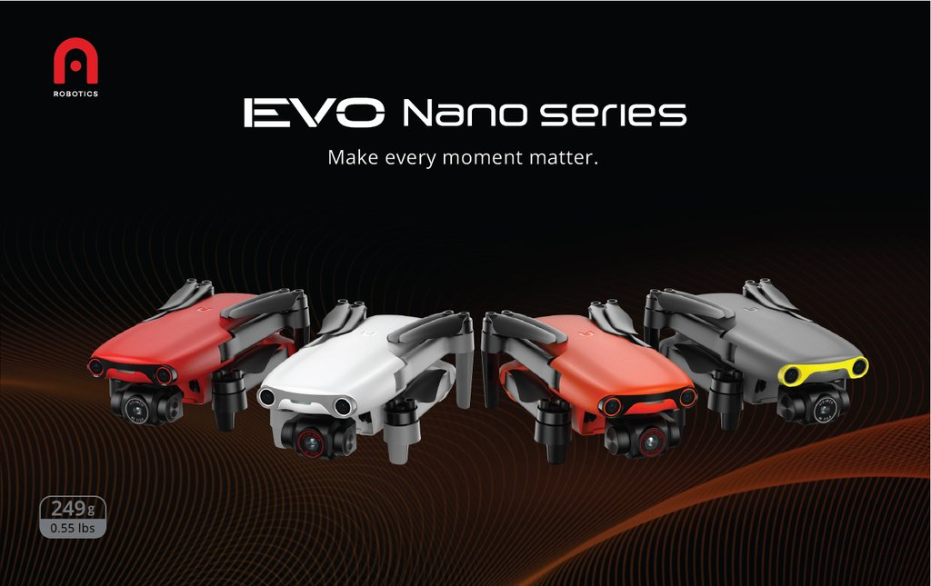

The Ultralight Companion For The Photography Enthusiast
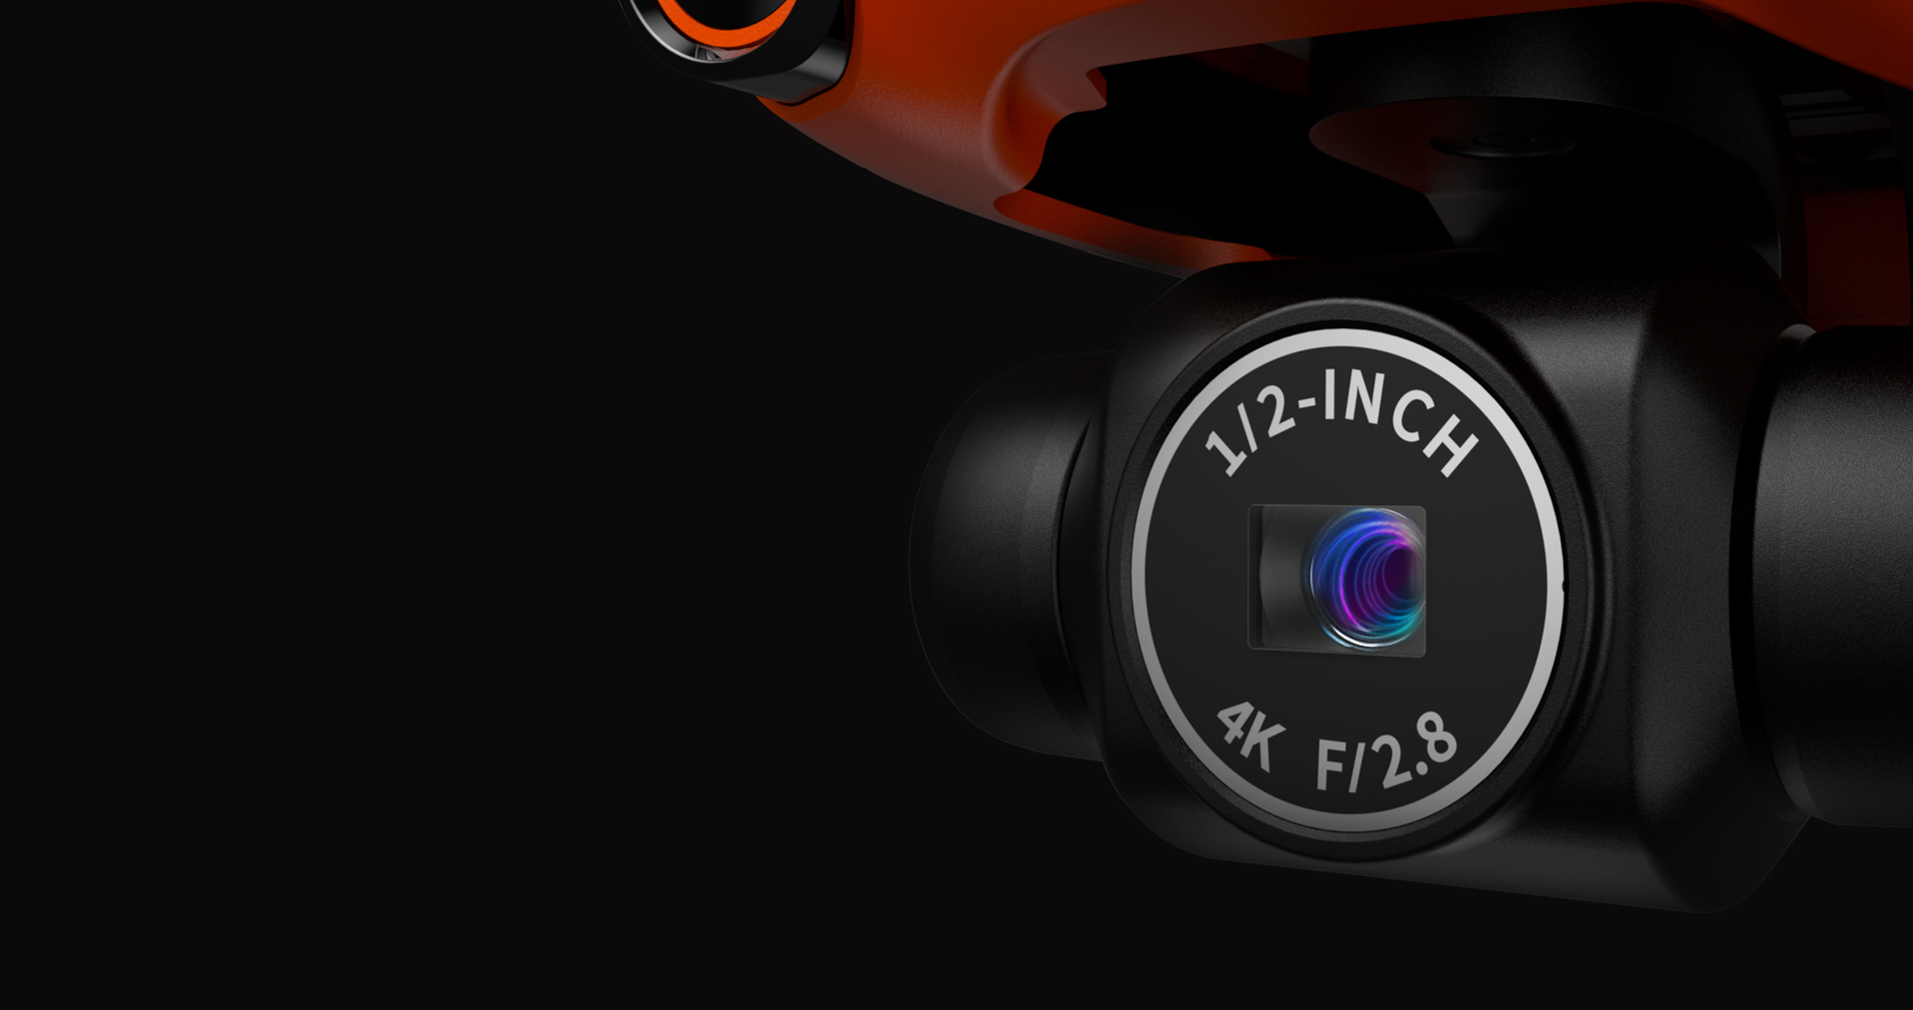

Super Sharp. Ultra Smooth.
The EVO Nano is equipped with a 48MP camera that can record ultra sharp 4K/30fps video. Paired with a three-axis mechanical gimbal to prevent vibration, the Nano provides everything you need to ensure your footage is smooth and stable no matter how rough the conditions.
- 1/2″ CMOS 3-axis Gimbal

HDR: Darker Shadows. Brighter Highlights.
With HDR on, Nano and Nano+ Will snap several photos at different exposures and automatically stitch them together- resulting in a photo with more contrast and dynamic range.

Add A Splash Of Color
Life is more than one color — and now so is your drone. Dress to impress with an elegant Arctic White. Fly under the radar cool and
confident with a sleek Deep Space Gray. Make a statement with Blazing Red. Or go boldly into the unknown with the classic Autel Orange.
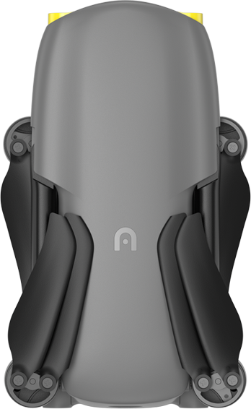

Deep Space Gray
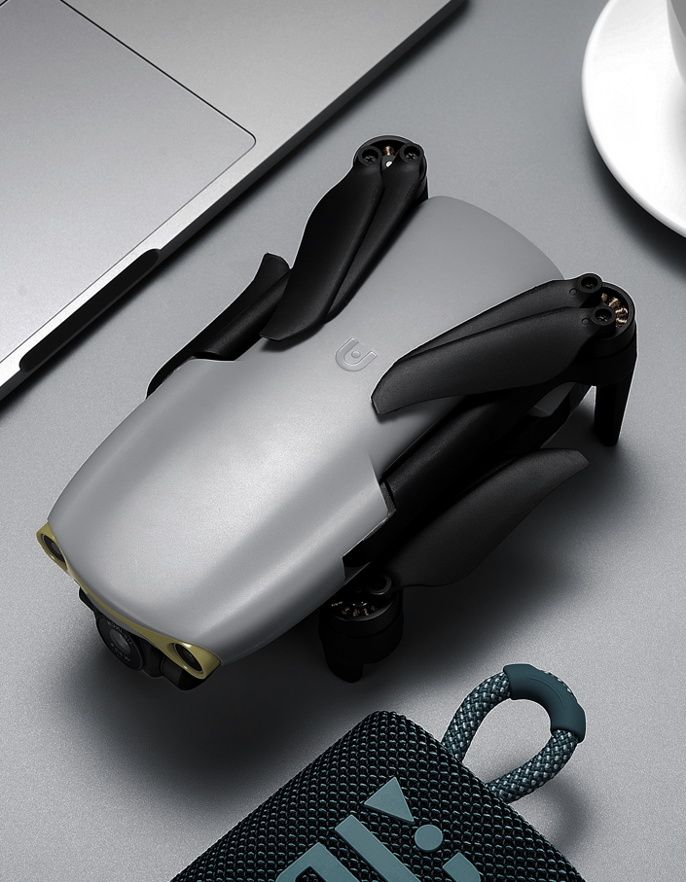
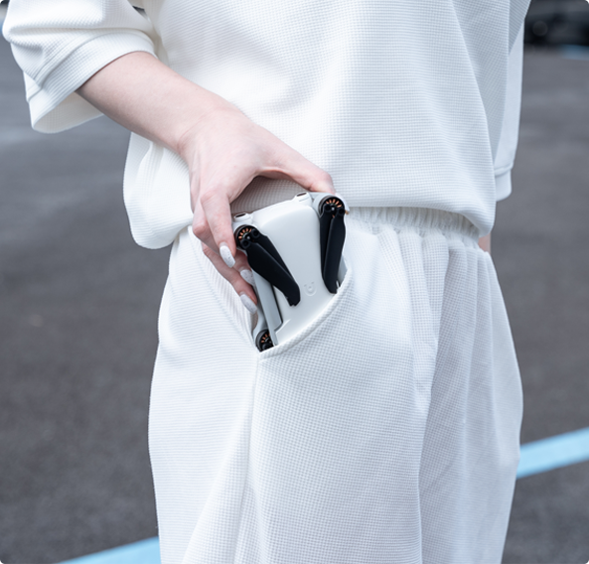
- Superlight. Ultracompact.
At only 249 grams, the EVO Nano and Nano+ weighs about as much as a smartphone and fits almost anywhere- from the side pocket of your hiking pack to the palm of your hand.

SkyPortrait: Your Personal Paparazzi
With the touch of a button, the Nano will rise into the air and snap a photo of you and your friends, automatically adjusting the lens so no one gets left out. Blur the background automatically for additional cinematic effect or dramatically reveal your epic destination — whether it’s the top of a mountain or your own backyard.

Dynamic Track 2.1: Master Subject Tracking
Recruit your Nano to automatically follow any person, animal, or vehicle so you can focus on your activities while your Nano handles the cinematic side.

Cinematic Shots Proficiency With A Single Click
Create dramatic, professional-level shots at the touch of a button with four automatic shooting modes. Add a soundtrack and filters in the Autel Sky app to make your video even more epic, allowing you to produce unforgettable results whether you’re a veteran pilot or completely new to the drone game.
- ROCKET
- FADE AWAY
- ORBIT
- FLICK

MovieMaster:

Easy Movie Making And Sharing
The Autel Sky app provides you a suite of video templates for quick and easy movie-making, allowing you to drastically reduce the tedious editing process so you can create share your creations on the spot!
- Easy Editing Imaginative Templates SuperDownload
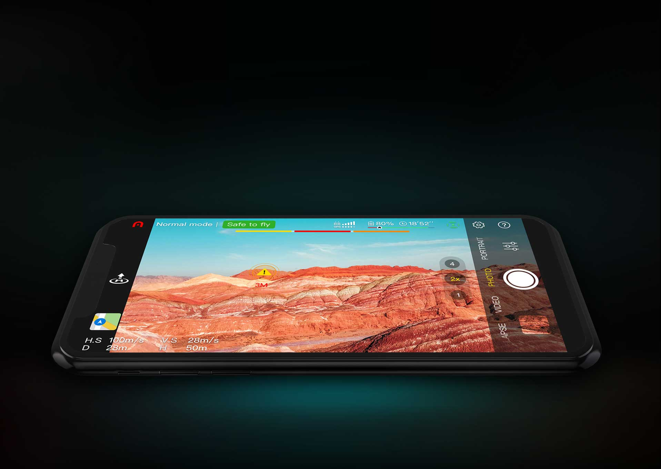

SkyLink Video Transmission

Fly Free—More Range, Less Interference
Fly farther while maintaining crisp, clear visuals with the all new Autel SkyLink, our strongest image transmission system yet, which offers a transmission range of 6.2 miles, transmission quality of 2.7K/30FPS, and superior anti-interference capabilities, all while relaying stunning QHD video.
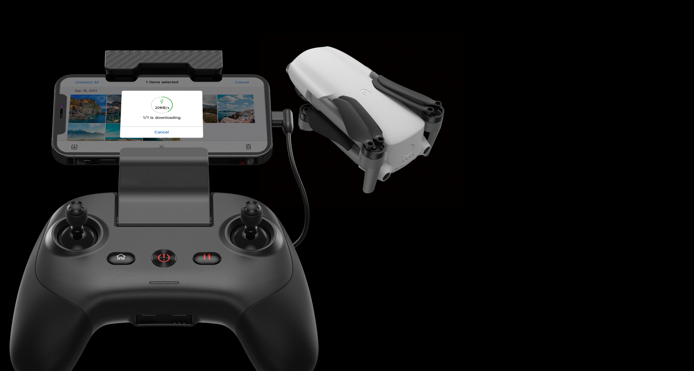
- SuperDownload
Done shooting? Simply place your smartphone close to the Lite to download photos and videos at a speedy rate of 160Mbps(20MB/s) using the Autel Sky app.
- SoundRecord: Bring Your Videos To Life
Record voices and ambient sounds on the ground through the smartphone, allowing you to bring your videos to life even when your drone is far away or use it to narrate while filming for better editing workflow.

Fly Safe With Advanced Obstacle Avoidance
The EVO Nano series is the first and only aircraft series of its size to offer an advanced obstacle avoidance system — making it the obvious choice for users looking to avoid crashes and preserve the life of their aircraft. With three-way binocular vision sensors that enable the drone to perceive obstructions in front of it, behind it, and below it. The EVO Nano series can easily brake to avoid collisions and navigate obstacles.
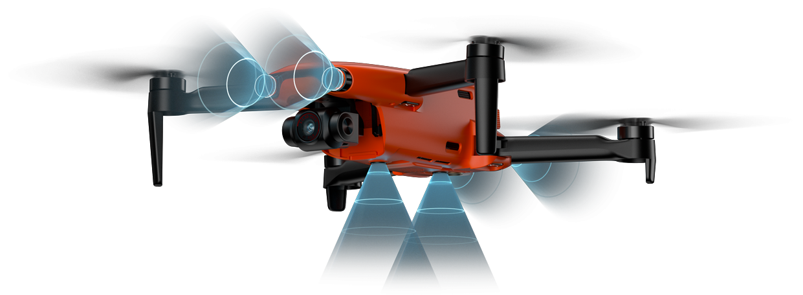

More Battery. More Time. More Creativity.
The EVO Nano can fly continuously for 28 minutes, which means plenty of time to experiment with creative angles and dream up inventive shots.
