EVO Lite Premium Bundle Gray, Autel

1.549,00 € χωρίς Φ.Π.Α.

Instant Lightweight Champion

EVO Lite World’s First 4-axis Gimbal Design
The EVO Lite is the first drone in the world to introduce a four-axis gimbal design, enabling you to shoot vertical videos for easy editing and sharing on mobile devices.

Supersensitive 50MP Camera
Experience a new level of image quality thanks to a supersensitive 50MP camera equipped with a 1/1.28-inch CMOS sensor. The camera adopts an RYYB color filter array design, which absorbs 40% more light than traditional RGGB arrays, allowing you to capture natural scenery in all its glory.
Available on back-order

In the Box
1 | EVO Lite Aircraft (including battery, propellers and gimbal cover) | 1x
2 | Remote Control | 1x
3 | Spare Battery | 2x
4 | Power Adapter | 1x
5 | Multi-Charger (3slot) | 1x
6 | Spare Propellers (pair) | 3x
7 | RC Charging Cable | 1x
8 | RC Cable | 3x
 | · Micro-USB Connector
 | · Lightning Connector
 | · USB-C Connector
9 | ND Filters Set | 1x
10 | Shoulder Bag | 1x
11 | Manuals | 4x
 | · Packing List
 | · Disclaimer & Safety Instructions
 | · EVO Lite Series Quick Start Guide
 | · Multi-channel Charger Guidelines

Aircraft
Takeoff weight | 835g
Dimensions (including blades) | Folded: 210×123×95mm  Unfolded: 427×384×95mm
Wheelbase | 368mm
Max ascent speed | 8m/s (sport), 5m/s (normal), 3m/s (stable)
Max descent speed | 4m/s (sport), 3m/s (normal), 2m/s (stable)
Max level flight speed(no wind, near sea level) | 19m/s (sport), 10m/s (normal), 5m/s (stable)
Max takeoff altitude | 5000m
Max flight time (no wind) | 40min
Max hovering time (no wind) | 38min
Max flight distance (no wind) | 24km
Max wind resistance | Level 7
Max tilt angle | 33°(movement), 25°(normal), 25°(stable)
Max angular velocity | 200°(movement), 120°(normal), 60°(stable)
Operating temperature | 0°C ~ 40°C
Operating frequency | 2.400-2.4835GHz，5.725-5.850GHz,5.150-5.250GHz
Transmission power (EIRP) | FCC:≤30dBm
GNSS | GPS
Hovering accuracy | Vertical:±0.1m (when the visual positioning is active), ±0.5m (with GPS positioning); Horizontal:±0.3m (when the visual positioning is active), ±1.5m (with GPS positioning);

Camera Lite
Sensor | CMOS: 1/1.28 inch  Effective pixels: 50M  Pixel size: 1.22μm*1.22μm
Lens | FOV: 85°  Equivalent focal length: 23mm  Aperture: f/1.9  Focus range: 0.5m ~ ∞  Focus mode: PDAF+CDAF/MF
Shooting mode | Automatic mode (P gear): EV adjustable, ISO/Shutter automatic  Manual mode (M gear): ISO/Shutter adjustable, EV not adjustable  Shutter priority (S gear): Shutter/EV adjustable, ISO automatic
ISO range | Video: ISO100 ~ ISO6400  Photo: ISO100 ~ ISO6400  Night scene mode: ISO up to 64000
Shutter speed | Photo mode: 1/8000 ~ 8s  Other: 1/8000 ~ 1/frame rates
Portrait blur | Real-time image transmission portrait blur and photo portrait blur
Defog mode | Support
Zoom range | Digital zoom: 1 ~ 16 times  Lossless zoom: 4K: 2 times; 1080p: 4 times  Note:  4K: more than 2 times the digital, the following is lossless  1080P: more than 4 times the digital, the following is lossless
Photo format | JPG(8-bit) / DNG(10-bit) / JPG+DNG
Photo resolution | 50MP：8192×6144（4:3）  12.5MP：4096×3072（4:3）  4K：3840×2160（16:9）
Photo shooting mode | Single shot  Burst shooing: 3/5  Auto exposure bracketing(AEB): 3/5 shots  Interval: 2s/3s/4s/5s (default)/6s/…/60s (DNG min 5s)  HDR imaging: 8192×6144/4096×3072/3840×2160  HyperLight: 8192×6144/4096×3072/3840×2160
Video coding format | H265/H264
Video resolution | 3840×2160 p60/50/48/30/25/24  2720×1528 p60/50/48/30/25/24  1920×1080 p120/60/50/48/30/25/24  HDR:  3840×2160 p30/25/24  2720×1528 p30/25/24  1920×1080 P60/50/48/30/25/24
Max bitrate | 120Mbps
Timelapse | Original image：3840*2160，JPG/DNG  Video：4K P25
Panorama | Horizontal/Vertical/Wide-angle/Spherical  Original image: 4096*3072，JPG/DNG
Supported file system | Fat32、exFat
Video format | MP4/MOV(8-bit)
WIFI transfer | 20MB/s

NEW PERSPECTIVES. NEW POSSIBILITIES.

Cut Through The Darkness. Take Back The Night.

Discover The World By Moonlight
Equipped with a 1-inch CMOS image sensor and Autel’s intelligent moonlight algorithm, the EVO Lite+ can capture crisp, vibrant details at night with low noise — even when the ISO is cranked up high.

Take Control With An Adjustable Aperture
Flex your creativity with an adjustable aperture from f/2.8-f/11, giving you the ability alter exposure and depth of field in imaginative ways that show off your unique artistic style.
- 1″ CMOS
- F2.8~F11
- 6K/30FPS Video
- 20MP

Restore Natural Colors
Automatically balance overexposure and underexposure when shooting scenes with too much contrast, producing clearer images with more layers.

Defog Mode
Whether you’re flying over a gloomy hilltop at dawn or hovering at the base of a waterfall, cut through the haze with a fog penetration function that automatically adjusts the camera’s vibrance settings to make your footage look crisp and clear.
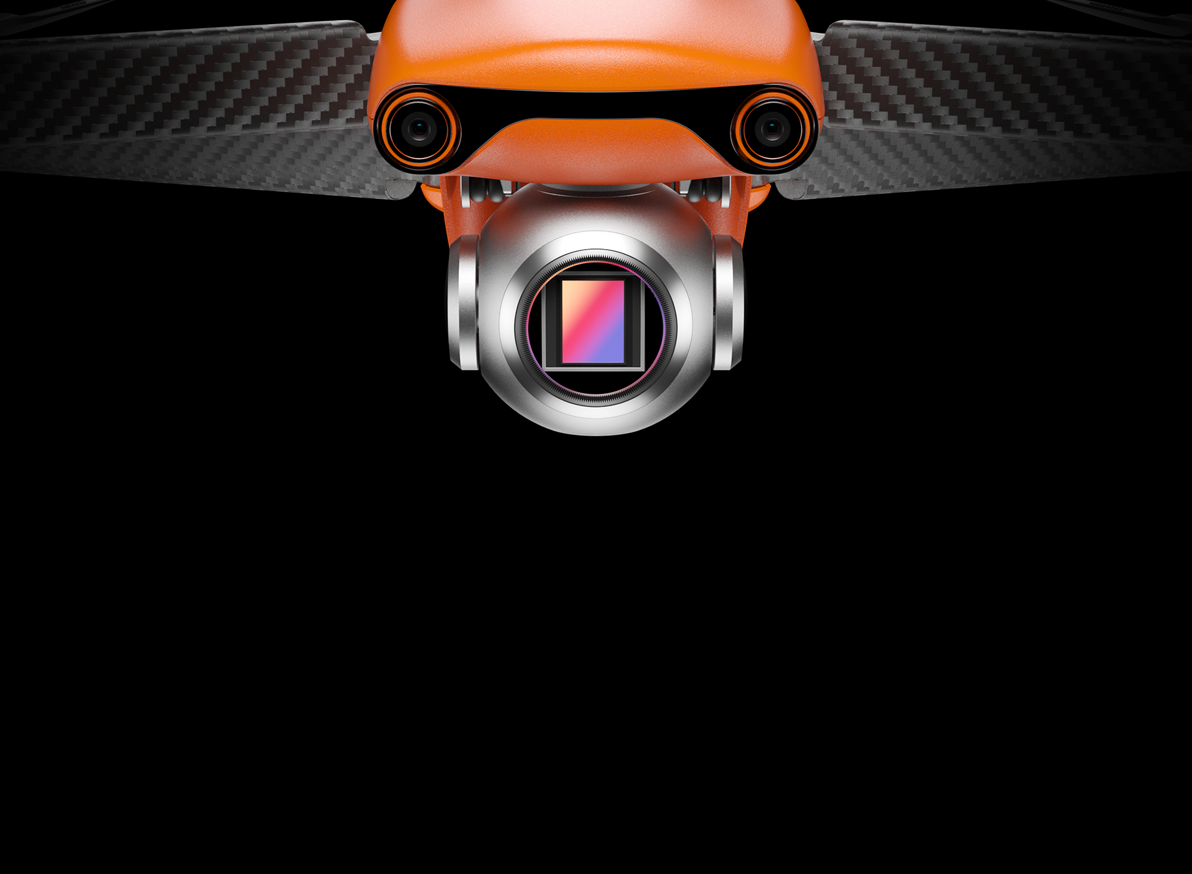

Instant Lightweight

Champion

World’s First 4-axis Gimbal Design
The EVO Lite is the first drone in the world to introduce a four-axis gimbal design, enabling you to shoot vertical videos for easy editing and sharing on mobile devices.

Supersensitive 50MP Camera
Experience a new level of image quality thanks to a supersensitive 50MP camera equipped with a 1/1.28-inch CMOS sensor. The camera adopts an RYYB color filter array design, which absorbs 40% more light than traditional RGGB arrays, allowing you to capture natural scenery in all its glory.
- RYYB
Sensor
- 50MP
Photo
- 4K HDR
Video
- 1/1.28″(0.8″)
CMOS
- PDAF+CDAF
Autofocus System

HDR: Darker Shadows. Brighter Highlights.
With HDR on, Nano and Nano+ Will snap several photos at different exposures and automatically stitch them together- resulting in a photo with more contrast and dynamic range.

Instant Focus, Instant Capture
Track fast-moving subjects with a precise autofocus that locks in within milliseconds using a phase detection autofocus and dual focus algorithm.

More Colors. More Choices.
Fly with style with a new selection of drone colors.
Dress to impress with an elegant Arctic White.
Fly under the radar cool and confident with a sleek Deep Space Gray.
Or go boldly into the unknown with the classic Autel Orange.
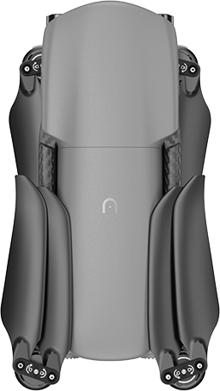

Cinematic Shots Proficiency With A Single Click
Create dramatic, professional-level shots at the touch of a button with four automatic shooting modes. Add a soundtrack and filters in the Autel Sky app to make your video even more epic, allowing you to produce unforgettable results whether you’re a veteran pilot or completely new to the drone game.
- FLICK
- ROCKET
- FADE AWAY
- ORBIT

SkyPortrait: Your Personal Paparazzi
With the touch of a button, the Lite will rise into the air and snap a photo of you and your friends, automatically adjusting the lens so no one gets left out. Blur the background automatically for additional cinematic effect or dramatically reveal your epic destination — whether it’s the top of a mountain or your own backyard.

Dynamic Track 2.1: Master Subject Tracking
Recruit your Lite to automatically follow any person, animal, or vehicle so you can focus on your activities while your Lite handles the cinematic side.
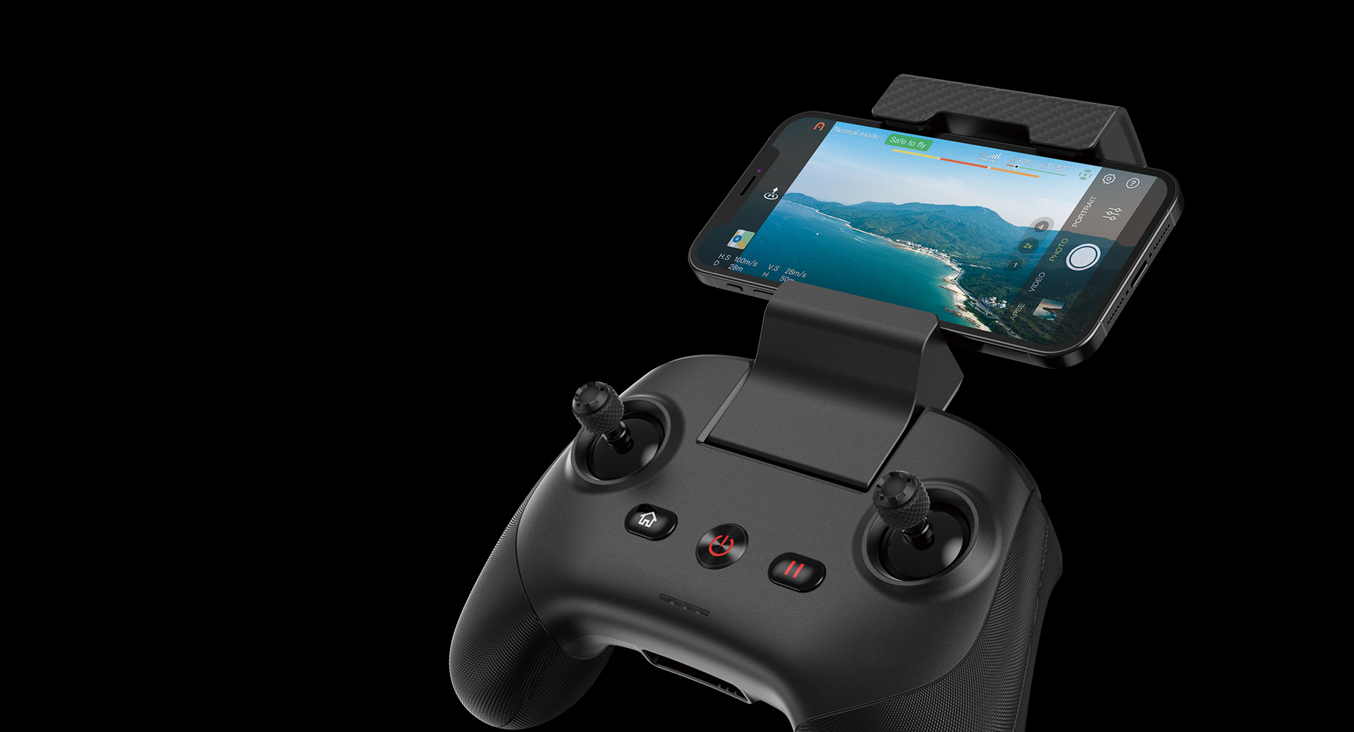

SkyLink Video Transmission

Fly Free—More Range, Less Interference
Fly farther while maintaining crisp, clear visuals with Autel SkyLink, our strongest image transmission system yet, which offers a transmission range of 7.4 miles, transmission quality of 2.7K/30FPS, and superior anti-interference capabilities, all while relaying stunning HD video.
- 2.4/5.8/5.2GHz
- 7.4 Miles
- 2.7K/30FPS
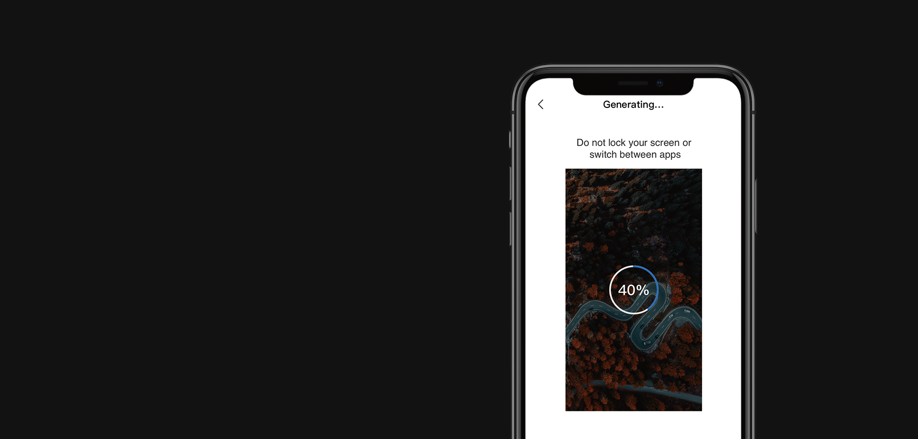
- SoundRecord: Bring Your Videos To Life
Record voices and ambient sounds on the ground through the smartphone, allowing you to bring your videos to life even when your drone is far away- or use it to narrate while filming for better editing workflow.
- SuperDownload
Done shooting? Simply place your smartphone close to the Lite to download photos and videos at a speedy rate of 160Mbps(20MB/s) using the Autel Sky app.
- MovieMaster: Easy Movie Making And Sharing
The Autel Sky app provides you a suite of video templates for quick and easy movie-making, allowing you to drastically reduce the tedious editing process so you can create share your creations on the spot!

Ultra Wide Angle Obstacle Avoidance
Fly faster, safer, and more confidently than ever before with Autel’s new ultra wide angle obstacle avoidance cameras. The sensors give the EVO Lite a front field of view of 150 degrees, eliminating more blindspots than traditional systems while reducing the number of cameras needed.
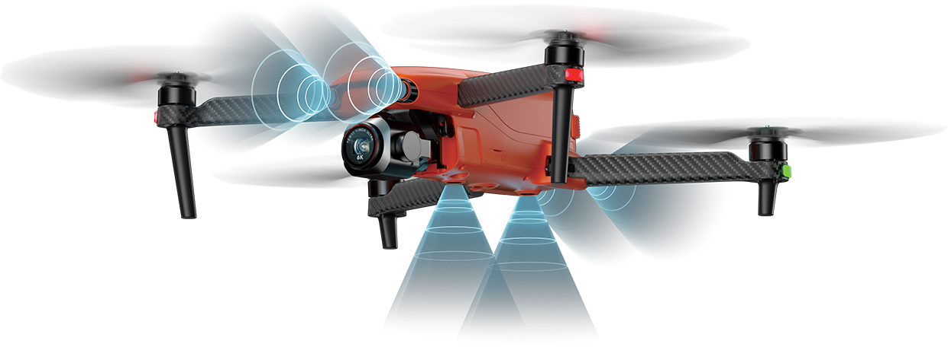

Industry-leading Battery Life
The EVO Lite is the only drone of its size to offer an endurance of 40 minutes, giving you 30 percent more flight time than the competition.
